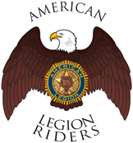

Department of Florida
The American Legion Riders
Chapter 138

Welcome new Applicant to ALR 138,

You have taken the first step in the process of becoming a Rider.
Please join us for a monthly meeting so we can get to know you and verify your eligibility in the American Legion Family and collect other information from you.
- Our Meetings are typically the 3rd Saturday of every month at 9:30am.
- If you can not make it to a meeting, please talk to one of the ALR officers or feel free to email us at Bikesbythebay138@gmail.com with any questions.

We look forward to welcoming you to our Family. Until the next meeting, please feel free to check out our corkboard with the latest events and follow us on Facebook at https://www.facebook.com/alr138

See you soon at the Post,

Rick Warner
ALR 138 Director
District 15 ALR Vice Chair
(813)787-2127

“For the cause, NOT the applause”

